Ejercicios de prueba Programa AutomatizacionMetodosGranMYDosFases

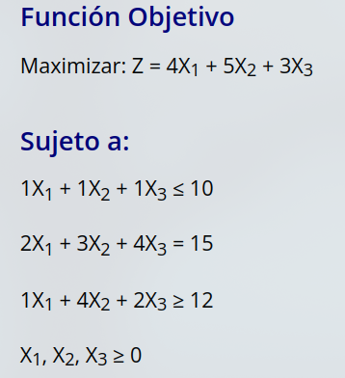

Solución maximizar Dos fases

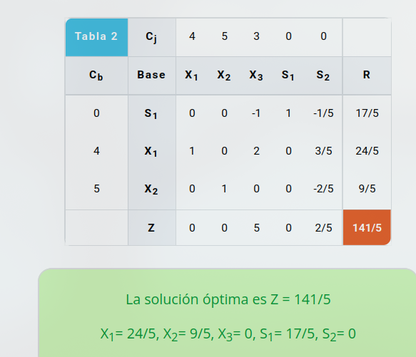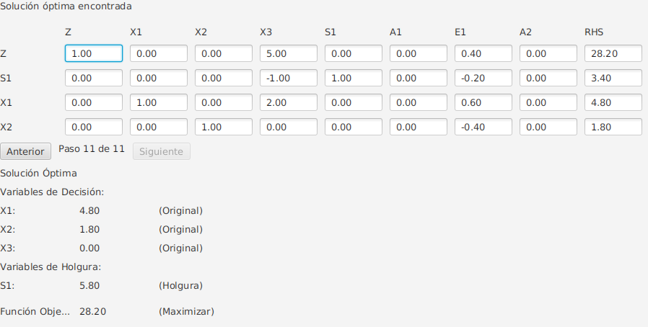

[Solución](https://www.plandemejora.com/calculadora-metodo-simplex-online/?problem=('cr![*17762.3.461.4.2-]~co!*4.5.3-~s!*≤.=.≥-~r!*107572-~o!'Maximizar')*['-'].'~6-,*7.1 76.-*_)

Solución maximizar Gran M

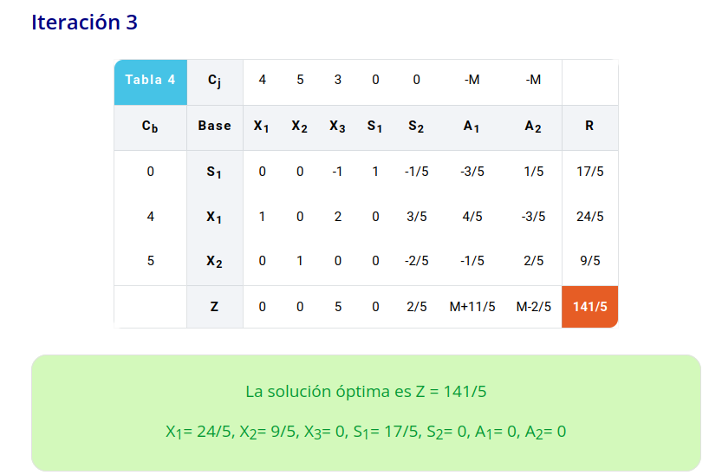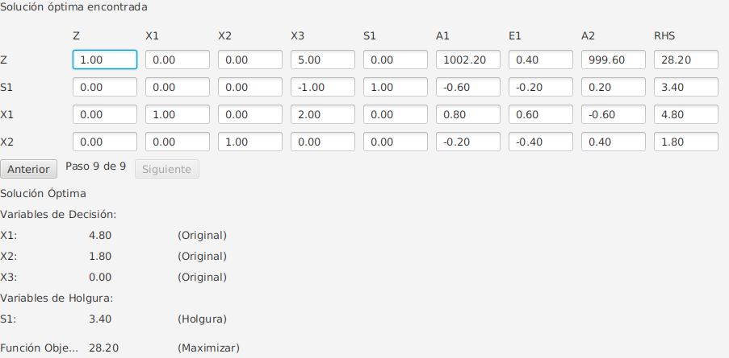

[Solución](https://www.plandemejora.com/calculadora-metodo-m-grande/?problem=('cr![*17762.3.461.4.2-]~co!*4.5.3-~s!*≤.=.≥-~r!*107572-~o!'Maximizar')*['-'].'~6-,*7.1 76.-*_)

Solución Minimizar Dos Fases

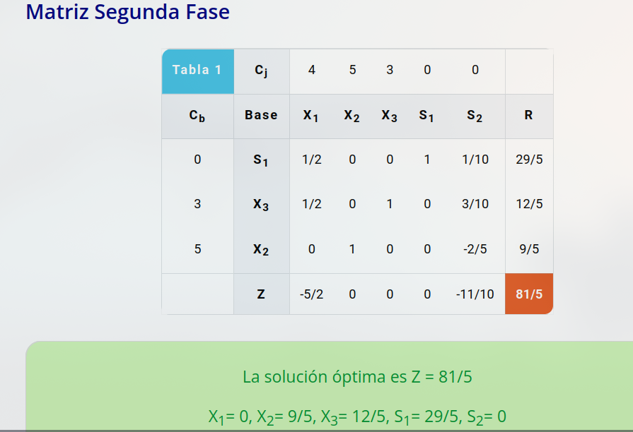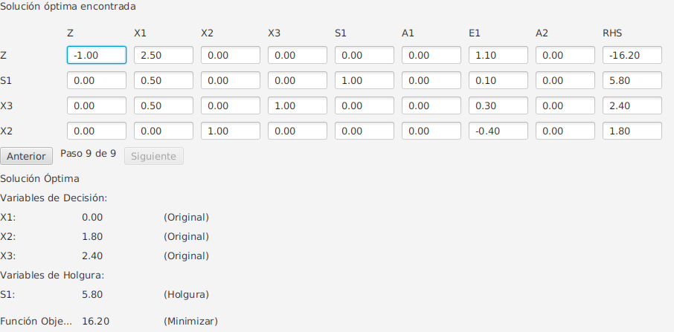

[Solución](https://www.plandemejora.com/calculadora-metodo-simplex-online/?problem=('cr![*17762.3.461.4.2-]~co!*4.5.3-~s!*≤.=.≥-~r!*107572-~o!'Minimizar')*['-'].'~6-,*7.1 76.-*_)

Solución minimizar Gran M

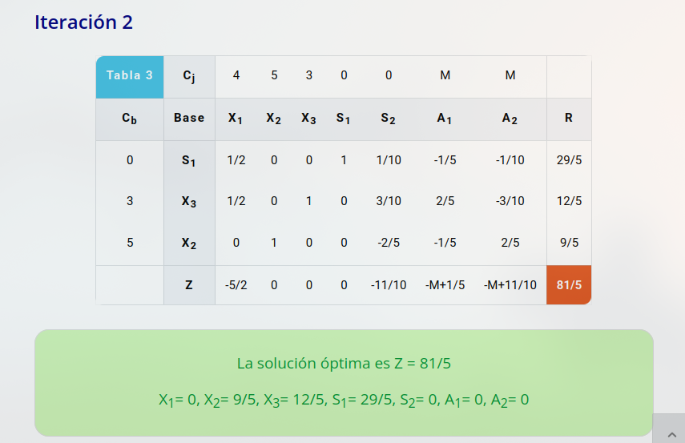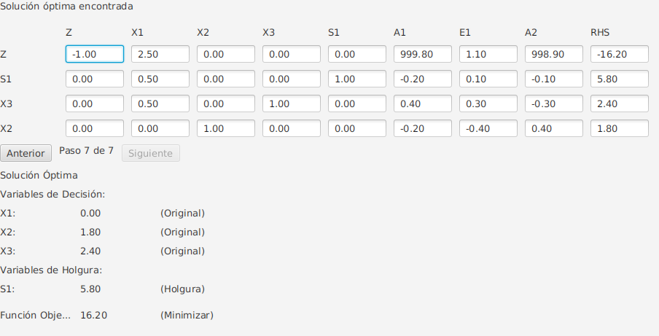

[Solución](https://www.plandemejora.com/calculadora-metodo-m-grande/?problem=('cr![*17762.3.461.4.2-]~co!*4.5.3-~s!*≤.=.≥-~r!*107572-~o!'Minimizar')*['-'].'~6-,*7.1 76.-*_)

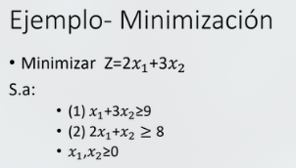

Minimizar Dos Fases

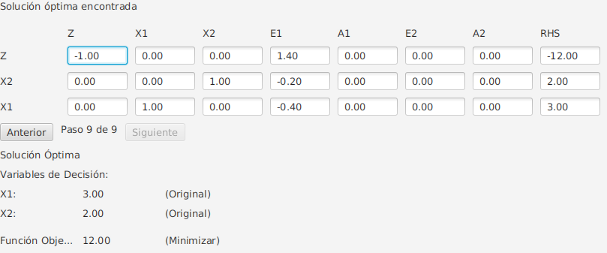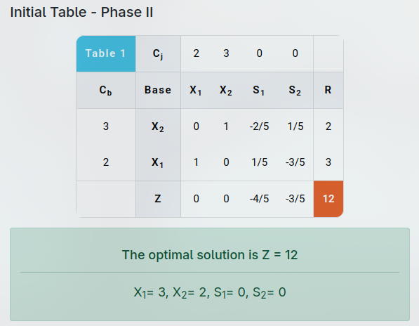

[Solucion](https://www.pmcalculators.com/simplex-method-calculator/?problem=('cr![*1.,*2'~1-]~co!*2.~s!*≥'~≥-~r!*9'~8-~o!'Minimizar')*['-'].'~3- .-*_)

Minimizar Gran M

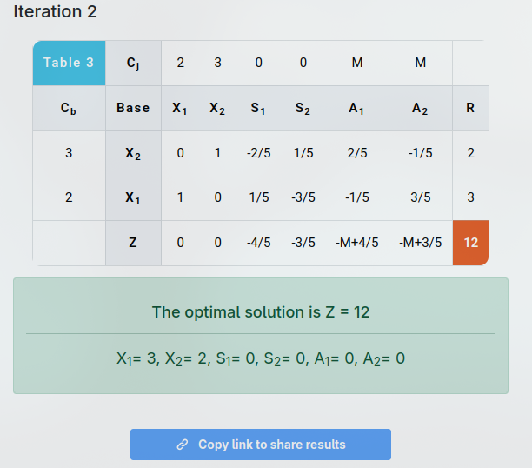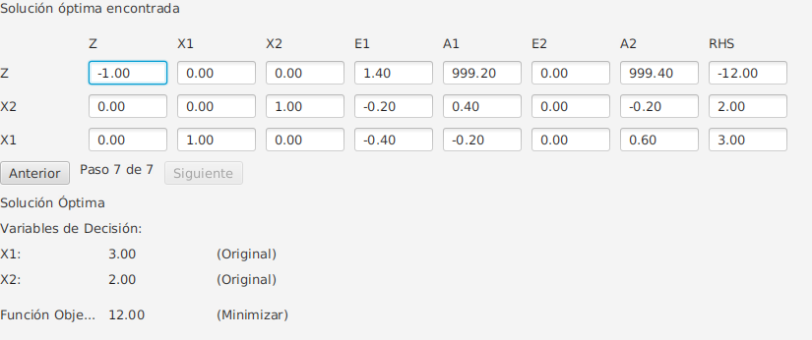

[Solución](https://www.pmcalculators.com/big-m-method-calculator/?problem=('cr![*1.,*2'~1-]~co!*2.~s!*≥'~≥-~r!*9'~8-~o!'Minimizar')*['-'].'~3- .-*_)

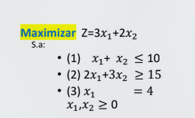

Dos Fases

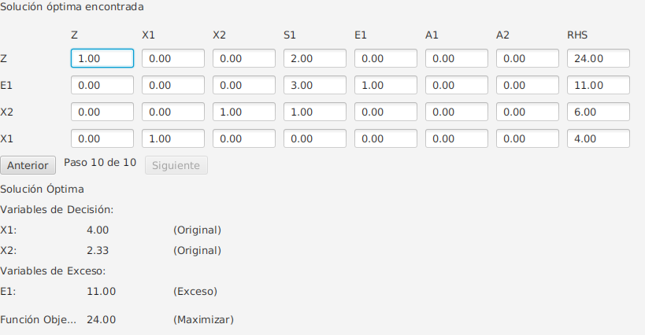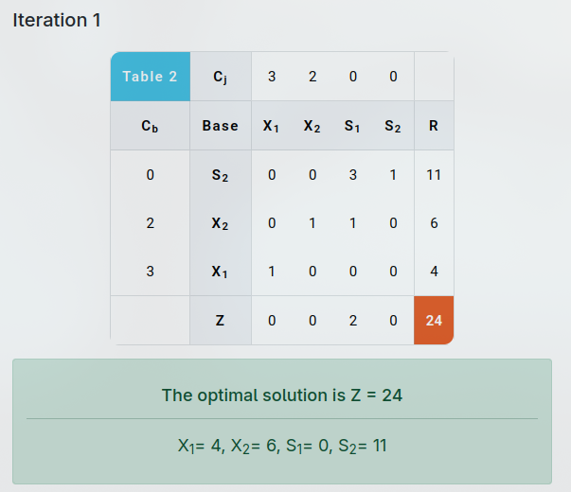

[Solución](https://www.pmcalculators.com/simplex-method-calculator/?problem=('cr![*1.162.361.0-]~co!*3.2-~s!*≤.≥.=-~r!*10.15.4-~o!'Maximizar')*['-'].'~6-,* 6.-*_)

Gran M

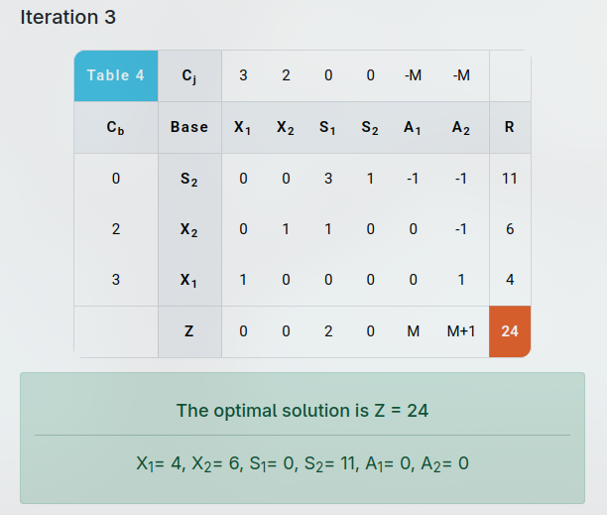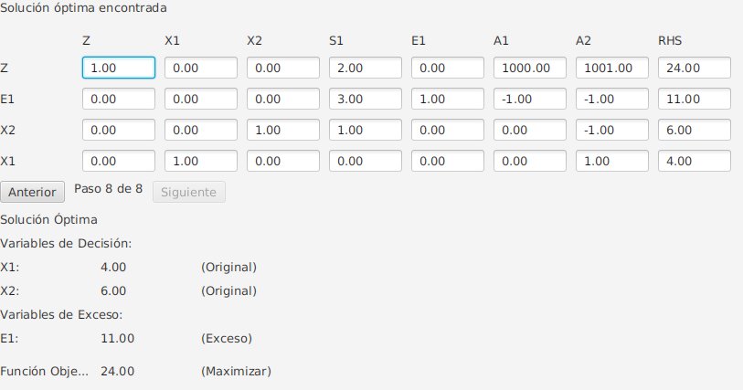

[Solución](https://www.pmcalculators.com/big-m-method-calculator/?problem=('cr![*1.162.361.0-]~co!*3.2-~s!*≤.≥.=-~r!*10.15.4-~o!'Maximizar')*['-'].'~6-,* 6.-*_)

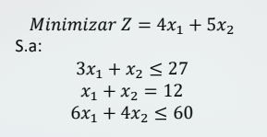

Dos Fases

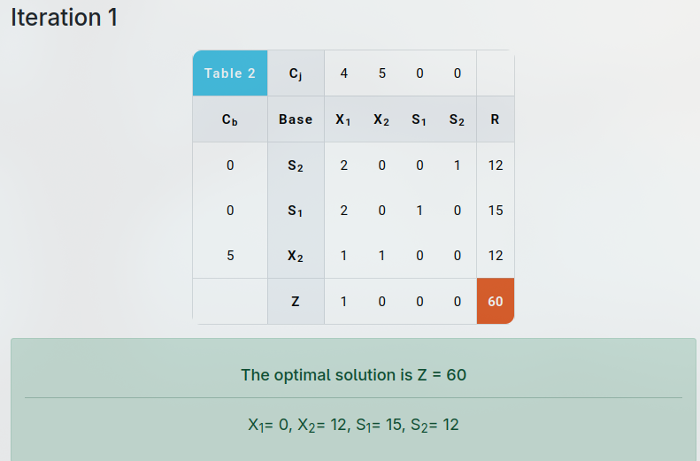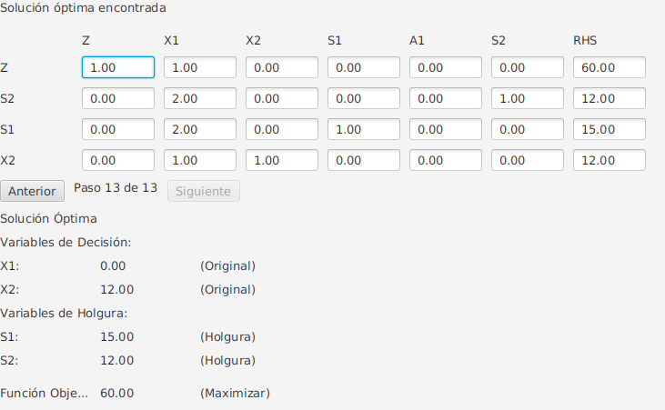

[Solución](https://www.pmcalculators.com/simplex-method-calculator/?problem=('cr![*38186.4-]~co!*4.5-~s!*≤.=.≤-~r!*27.12.60-~o!'Maximizar')*['-'].'~8.1-,* 8.-*_)

Gran M

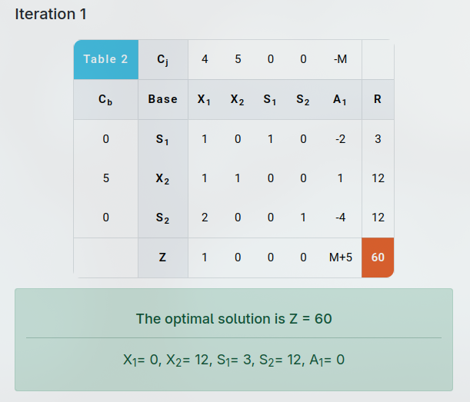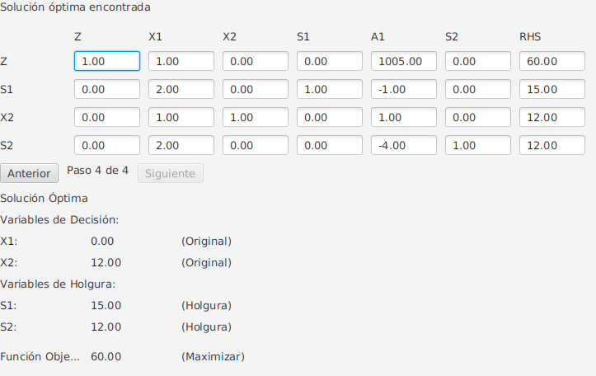

[Solución](https://www.pmcalculators.com/big-m-method-calculator/?problem=('cr![*3.281.186.4-]~co!*4.5-~s!*≤.=.≤-~r!*27.12.60-~o!'Maximizar')*['-'].'~8-,* 8.-*_)

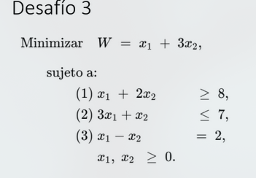

Dos Fases

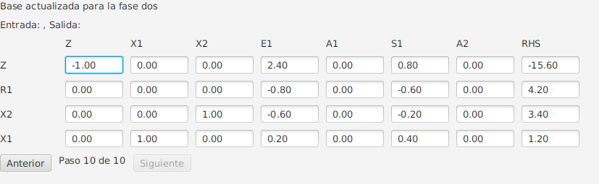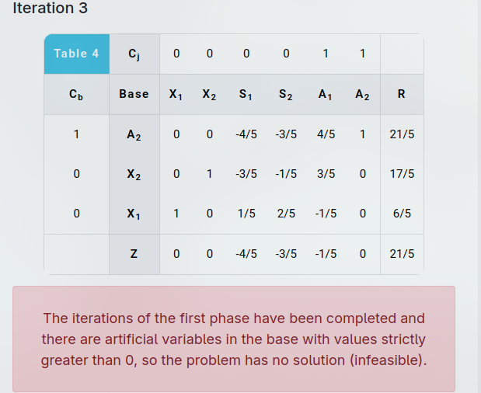

[Solución](https://www.pmcalculators.com/simplex-method-calculator/?problem=('cr![425*30154-1.]~co!43.~s!*≥0≤0=.~r!*80702.~o!'Minimizar')*['.']0'~4*105., 540.*_)

Gran M

